**Gym Fitness Management System**

**1. Introduction**

**Project Overview**

The Gym Fitness Management System is designed to streamline and automate the daily operations of a gym. By transitioning from manual, paper-based processes to a digital platform, this system aims to improve the efficiency of gym management, enhance the experience for gym members, and provide robust tools for trainers and administrators. The system includes features such as user registration and management, membership plan management, workout scheduling, attendance tracking, payment processing, and feedback collection.

**Objectives**

The primary objectives of the Gym Fitness Management System are:

- To digitize all manual activities associated with gym management.

- To simplify the administrative tasks for gym staff, reducing the complexity and time involved in managing records on paper.

- To provide gym members with an online platform to track their attendance, manage their schedules, and access personalized workout plans.

- To enable guest users to apply for gym memberships online.

- To facilitate trainers in managing their schedules and tracking member progress through a centralized system.

- To ensure secure and efficient processing of membership payments.

- To collect and manage feedback from gym members to continuously improve services.

**Scope**

The scope of the Gym Fitness Management System includes:

- Developing a web-based application accessible by administrators, trainers, members, and guest users.

- Creating a robust backend database to store all relevant data, including user information, membership plans, workout schedules, attendance records, payments, and feedback.

- Implementing user authentication and authorization to ensure data security and privacy.

- Providing an intuitive user interface that allows for easy navigation and usage of the system.

- Generating reports and analytics to help gym management make informed decisions.

- Excluding mobile app development and third-party integrations in the initial phase.

**2. Requirements Analysis**

**Functional Requirements**

1. User Management

- Admin can create, view, update, and delete user profiles (admins, trainers, members, and guests).

- Users can register, log in, and manage their profiles.

- Role-based access control to ensure different permissions for admins, trainers, and members.

2. Membership Management

- Admin can create, view, update, and delete membership plans.

- Members can view available membership plans and their own membership details.

- Admin can assign membership plans to members and update membership status.

3. Workout and Schedule Management

- Trainers can create and manage workout schedules and diet charts for members.

- Members can view their personalized workout plans and schedules.

4. Attendance Tracking

- Admin and trainers can mark and view attendance for users.

- Members can view their own attendance records.

5. Payment Processing

- Admin can manage and track payments for memberships.

- Members can view their payment history and make payments online.

6. Feedback Collection

- Members can provide feedback on gym services.

- Admin can view and manage feedback to improve gym operations.

7. Product Management

- Admin can manage gym products, including adding, updating, and deleting products.

- Members can view and purchase gym products online.

8. Order Management

- Members can place orders for gym products.

- Admin can view and manage orders, including tracking delivery status.

9. Reporting and Analytics

- Generate reports on user registration, membership plans, payments, attendance, and feedback.

- Provide filters and export options for detailed analysis.

**Non-Functional Requirements**

1. Performance

- The system should handle concurrent user access without significant performance degradation.

- Database queries should be optimized for fast retrieval and updates.

2. Security

- Implement strong authentication and authorization mechanisms to protect user data.

- Encrypt sensitive data, such as passwords and payment information, both in transit and at rest.

3. Usability

- Provide a user-friendly interface with clear navigation and instructions.

- Ensure the system is accessible on various devices and browsers.

4. Scalability

- Design the system to accommodate future growth in the number of users and data volume.

- Implement scalable architecture and database design to handle increased load.

5. Reliability

- Ensure high availability of the system with minimal downtime.

- Implement regular backups and disaster recovery procedures to protect data integrity.

**3. Database Design Process**

Methodology

The database design for the Gym Fitness Management System follows a structured approach to ensure a well-organized, efficient, and scalable database. The design process is divided into several stages, including conceptual design, logical design, and physical design. The following methodologies are employed:

1. Requirement Analysis: Understanding the functional and non-functional requirements to determine the necessary data and relationships.

2. Conceptual Design: Creating an Entity-Relationship (ER) diagram to represent the entities, attributes, and relationships.

3. Logical Design: Translating the ER diagram into a relational schema and normalizing the tables to eliminate redundancy.

4. Physical Design: Implementing the schema in a DBMS, defining storage parameters, indexing strategies, and ensuring optimal performance.

**Tools and Technologies**

The database design and implementation utilize the following tools and technologies:

- DBMS: MySQL for database management.

- ER Diagram Tool: Software like draw.io for creating the ER diagram.

- SQL: Structured Query Language for defining and manipulating the database.

- Development Framework: Frameworks such as Spring for integrating the database with the application.

**4. Conceptual Design**

ER Diagram

The Entity-Relationship (ER) diagram visually represents the entities, attributes, and relationships in the Gym Fitness Management System. Below are the entities and their key attributes:

1. User_Type

* user_type_id (PK) - Integer
* type_name - (VARCHAR, e.g., Admin, Trainer, Member, Guest)

2. User_Master

* user_id (PK) - Integer
* user_type_id (FK) - Integer
* name - Varchar(100)
* email - Varchar(100) (Unique)
* password - Varchar(100)
* gender - Char(1), e.g., 'M', 'F'
* profile_photo - Image
* address - Varchar(255)
* mobile_no - Varchar(15)
* date_of_birth - Date

3. Plan_Master

* plan_id (PK) - Integer
* plan_name - Varchar(50)
* plan_description - Text
* plan_duration - Integer (in months)
* plan_price - Decimal(10, 2)

4. Membership_Master

* membership_id (PK) - Integer
* user_id (FK) - Integer
* plan_id (FK) - Integer
* start_date - Date
* end_date - Date
* status - Varchar(20)

5. Trainer_Details

* trainer_id (PK) - Integer
* user_id (FK) - Integer
* specialization - Varchar(100)
* details - Varchar(255)
* experience - Integer (in years)
* salary - Integer

6. Payment_Master

* payment_id (PK) - Integer
* membership_id (FK) - Integer
* payment_date - Date
* amount - Decimal(10, 2)
* payment_method - Varchar(50)
* transaction_id - Varchar(100)
* payment_status - Varchar(50)

7. Product_Master

* product_id (PK) - Integer
* product_name - Varchar(100)
* product_image - Image
* product_description - Text
* price - Decimal(10, 2)
* quantity - Integer

8. Feedback_Master

* feedback_id (PK) - Integer
* user_id (FK) - Integer
* rating - Integer
* comments - Text
* feedback_date - Date

9. Workout_Master

* workout_id (PK) - Integer
* user_id (FK) - Integer
* trainer_id (FK) - Integer
* diet_chart - Text
* workout_schedule - Text
* workout_videos - Text
* reward_points - Integer

10. Order_Master

* order_id (PK) - Integer
* user_id (FK) - Integer
* order_date - Date
* delivery_date - Date
* order_status - Varchar(50)

11. Order_Details

* order_detail_id (PK) - Integer
* order_id (FK) - Integer
* product_id (FK) - Integer
* quantity - Integer
* price - Decimal(10, 2)

12. Attendance_Master

* attendance_id (PK) - Integer
* user_id (FK) - Integer
* attendance_date - Date
* status - Varchar(20)

**Relationships**

* User_Type is related to User_Master via `user_type_id`.
* User_Master is related to Membership_Master, Trainer_Details, Payment_Master, Feedback_Master, Workout_Master, Order_Master, and Attendance_Master via `user_id`.
* Plan_Master is related to Membership_Master via `plan_id`.
* Membership_Master is related to Payment_Master via `membership_id`.
* Product_Master is related to Order_Details via `product_id`.
* Order_Master is related to Order_Details via `order_id`.
* Workout_Master is related to Trainer_Details via `trainer_id`.

1. **Logical Design**

**Data Model**

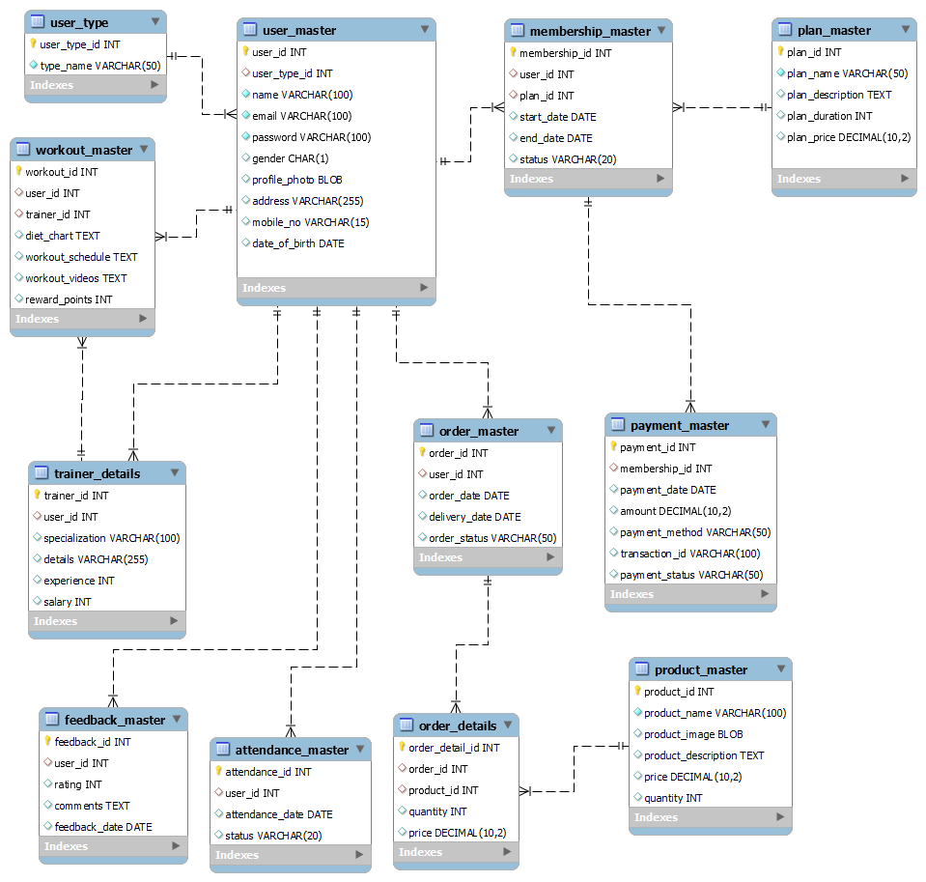

The logical design translates the conceptual ER diagram into a relational schema. Below are the table schemas:

1. User_Type

CREATE TABLE User_Type (

UserTypeID INT PRIMARY KEY,

UserTypeName VARCHAR(50) NOT NULL

);

2. User_Master

CREATE TABLE User_Master (

UserID INT PRIMARY KEY,

UserTypeID INT,

Name VARCHAR(100) NOT NULL,

Email VARCHAR(100) NOT NULL,

Gender VARCHAR(10),

Address VARCHAR(255),

MobileNo VARCHAR(15),

Password VARCHAR(255) NOT NULL,

FOREIGN KEY (UserTypeID) REFERENCES User_Type(UserTypeID)

);

3. Plan_Master

CREATE TABLE Plan_Master (

PlanID INT PRIMARY KEY,

PlanName VARCHAR(100) NOT NULL,

Duration INT NOT NULL,

Price DECIMAL(10, 2) NOT NULL

);

4. Membership_Master

CREATE TABLE Membership_Master (

MembershipID INT PRIMARY KEY,

UserID INT,

PlanID INT,

StartDate DATE NOT NULL,

EndDate DATE NOT NULL,

FOREIGN KEY (UserID) REFERENCES User_Master(UserID),

FOREIGN KEY (PlanID) REFERENCES Plan_Master(PlanID)

);

5. Trainer_Details

CREATE TABLE Trainer_Details (

TrainerID INT PRIMARY KEY,

UserID INT,

Specialization VARCHAR(100),

Experience INT,

FOREIGN KEY (UserID) REFERENCES User_Master(UserID)

);

6. Payment_Master

CREATE TABLE Payment_Master (

PaymentID INT PRIMARY KEY,

MembershipID INT,

Amount DECIMAL(10, 2) NOT NULL,

PaymentDate DATE NOT NULL,

PaymentMethod VARCHAR(50),

FOREIGN KEY (MembershipID) REFERENCES Membership_Master(MembershipID)

);

7. Product_Master

CREATE TABLE Product_Master (

ProductID INT PRIMARY KEY,

ProductName VARCHAR(100) NOT NULL,

Description TEXT,

Price DECIMAL(10, 2) NOT NULL,

Quantity INT NOT NULL

);

8. Feedback_Master

CREATE TABLE Feedback_Master (

FeedbackID INT PRIMARY KEY,

UserID INT,

FeedbackText TEXT,

Rating INT,

FeedbackDate DATE,

FOREIGN KEY (UserID) REFERENCES User_Master(UserID)

);

9. Workout_Master

CREATE TABLE Workout_Master (

WorkoutID INT PRIMARY KEY,

UserID INT,

TrainerID INT,

DietChart TEXT,

WorkoutSchedule TEXT,

WorkoutVideos TEXT,

RewardPoints INT,

FOREIGN KEY (UserID) REFERENCES User_Master(UserID),

FOREIGN KEY (TrainerID) REFERENCES Trainer_Details(TrainerID)

);

10. Order_Master

CREATE TABLE Order_Master (

OrderID INT PRIMARY KEY,

UserID INT,

OrderDate DATE NOT NULL,

DeliveryDate DATE,

DeliveryStatus VARCHAR(50),

FOREIGN KEY (UserID) REFERENCES User_Master(UserID)

);

11. Order_Details

CREATE TABLE Order_Details (

OrderDetailID INT PRIMARY KEY,

OrderID INT,

ProductID INT,

Quantity INT NOT NULL,

Price DECIMAL(10, 2) NOT NULL,

FOREIGN KEY (OrderID) REFERENCES Order_Master(OrderID),

FOREIGN KEY (ProductID) REFERENCES Product_Master(ProductID)

);

12. Attendance_Master

CREATE TABLE Attendance_Master (

AttendanceID INT PRIMARY KEY,

UserID INT,

AttendanceDate DATE NOT NULL,

Status VARCHAR(10) NOT NULL,

FOREIGN KEY (UserID) REFERENCES User_Master(UserID)

);

Normalization

The tables are designed to be in the third normal form (3NF):

- 1NF: Each table has a primary key, and all columns contain atomic values.

- 2NF: All non-key columns are fully functional dependent on the primary key.

- 3NF: All non-key columns are not transitively dependent on the primary key.

This ensures minimal redundancy and optimal data integrity.